A phenomenological model for micromixing
Frans Muller
This works concerns the description of mixing and reaction of systems where a feed with an concentration ${\left[B\right]}_{o}$ in mixed with a fluids containing a${\left[A\right]}_{o}≪{\left[B\right]}_{o}$. And the reaction between A and B is relatively fast:
$$τ_{rxn}=\frac{1}{k_{obs}} with k_{obs}=\frac{R_{A}}{{\left[A\right]}_{o}}=\frac{k_{AB}{\left[B\right]}_{o}{\left[A\right]}_{o}}{{\left[A\right]}_{o}}=k_{AB}{\left[B\right]}_{o}$$
In a fed batch system where a volume $V_{B}$ is fed over a period of time $τ_{f}$, and reaction is fast a pseudo steady state is reached:
$$\frac{V_{B}}{τ_{f}}*{\left[B\right]}_{o}=V_{bx} k_{AB}\left[B\right]{\left[A\right]}_{o}$$
$$\frac{1}{τ_{f}}⋅\frac{V_{B}}{V_{bx}}\frac{{\left[B\right]}_{o}}{{\left[A\right]}_{o}} = k_{AB}\left[B\right]$$
If we assume the accumulation ($β$) of B to be $β{\left[A\right]}_{o}$ then we can determine the observed rate:
$$\frac{1}{τ_{f}}⋅\frac{V_{B}}{V_{bx}}\frac{{\left[B\right]}_{o}}{{\left[A\right]}_{o}} = k_{AB}β{\left[A\right]}_{o}$$
$$k_{obs}=k_{AB}{\left[B\right]}_{o}=\frac{1}{{βτ}_{f}}⋅\frac{V_{B}}{V_{bx}}{\left(\frac{{\left[B\right]}_{o}}{{\left[A\right]}_{o}}\right)}^{2} and τ_{rxn}=βτ_{f}\frac{V_{bx}}{V_{B}}{\left(\frac{{\left[A\right]}_{o}}{{\left[B\right]}_{o}}\right)}^{2}$$
Assuming ${\left[B\right]}_{o}=10 {\left[A\right]}_{o}$, a feed time of 1 hr and an over all ration of A:B of 1:1 would give:
$$τ_{rxn}=β 3600\frac{10}{1}{\left(\frac{1}{10}\right)}^{2}=360 β$$
So at 1% accumulation the reaction time is 3.6 s, which is larger than the mezomixing time scales. For micromixng we would expect reaction times less then 1 ms indicating very low accumulation, $β≪{10}^{-4}$
Micro and mezo mixing are both driven by the formations of eddies at a range of scales. These eddies stretch and fold the volumes of unmixed A and B, ever increasing the interface between the two discrete zones. The idea is that only when the layers of a-b-a-b reach a thickness where diffusion can act on a time scale less than the reaction time the liquid volumes become homogeneous, and can reaction occur.
The mixing length over which diffusion occurs may be estimated from
$$L_{mix}=\sqrt{D_{m}t_{mix}}$$
For mezo mixing, $t_{mix}≈0.1 to 1 s$ which give $L_{mix}≈{10}^{-4} to {10}^{-5}$
For micro mixing, $t_{mix}≈0.001 to 0.01 s$ which give $L_{mix}≈{10}^{-5} to {10}^{-6}$
For fast kinetic systems, the degree to which A and B are segregated is important. The figure below demonstrates this.
The development of a large scale flow structures at the interface of A and B will, because of their rotation, form a spiral structure, thus increasing the interfacial area between the volume of A and B by:
$$ΔA_{mezo}=2\left(l/d_{e}-1\right)d_{e}⋅λ_{e}$$
With $d_{e}$the eddy diameter, $l$ the length of the spiral formed and $λ_{e}$the effective length of the eddy. We assume that eddies formed have their axis parallel to the interface between A and B. this is of course not always the case has the definition is the effective length of the eddies.
The concept of micro mixing is that at the smallest turbulent eddy length scales (~50 $μm$) the layers of ABAB reach the degree to which diffusion evens out the concentration differences over the live-time of the eddy. In other words a Kolmogorov eddy that forms on the interface between A and B ‘s volume will homogenise the material contained in that eddy at a molecular level. Depending on the concentrations of A and B in the resulting mixture, the resulting mixed volume is assigned to either
- volume B, if the concentration B is higher then $B_{lmt}$,
- volume A if the concentration is less then $B_{lmt}$ or
- volume A if the concentration A and B in the eddy are with in some limit $ΔC_{mix}$ of the volume A concentration
For (i) and (ii) the area increases by:
$$ΔA_{μ}=\frac{1}{2}\left(π-1\right)d_{μ}⋅λ_{μ}$$
In case (iii) the resulting volume is indistinguishable of the bulk, and the area is removed:
$$ΔA_{r}=-d_{μ}⋅λ_{μ}$$

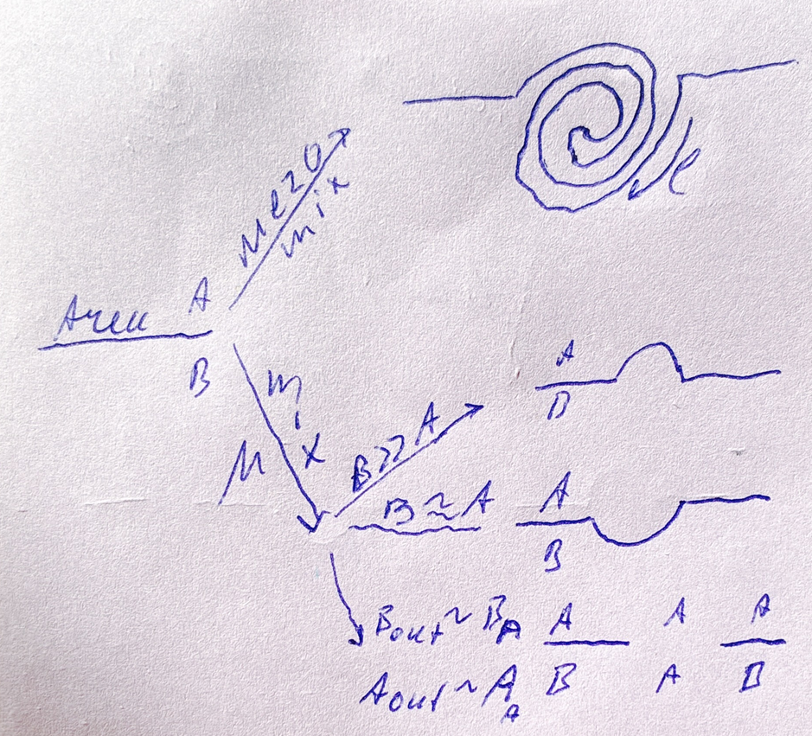

The formation rate of the interfacial area $A_{i}$can now be evaluated. Assuming we have $N_{mezo}$ and $N_{μ}$ eddies formed every period of mixing (i.e $τ_{mix})$per unit volume of fluid. This may be correlated to $ε$ the power dissipation per unit volume. The eddy will only affect the interface if its within one diameter of the interface, so the volume where eddies affect the interface is:
$$V_{i}=2A_{i}d_{e}$$
And the rate interface and the volumes of A and B change is then
$$\frac{dA_{i}}{dt}=\frac{2A_{i}d_{e}}{V_{tot}}\frac{N_{mezo}}{τ_{mezo}} 2\left(l/d_{e}-1\right)d_{e}⋅λ_{e}+\frac{2A_{i}d_{μ}}{V_{tot}} \frac{N_{μ}}{τ_{μ}} \frac{1}{2}\left(π-1\right)d_{μ}⋅λ_{μ}⋅(1-f_{r})$$
$$\frac{dV_{B}}{dt}=\frac{1}{2}\frac{2A_{i}d_{μ}}{V_{tot}} \frac{N_{μ}}{τ_{μ}}\frac{1}{4}πd_{μ}^{2}⋅λ_{μ}⋅(f_{B}-f_{A}-f_{r})$$
$$\frac{dV_{A}}{dt}=\frac{1}{2}\frac{2A_{i}d_{μ}}{V_{tot}} \frac{N_{μ}}{τ_{μ}} \frac{1}{4}πd_{μ}^{2}⋅λ_{μ}⋅\left(f_{A}+f_{r}-f_{B}\right)$$
With$f_{A}, f_{B}$ the fraction of eddies resulting in type A or B volume, and $f_{r}$ the fraction of micro mixed eddies that are considered to be equivalent to bulk.
To evaluate the change in the concentration we consider the likely hood the eddie forms with its centreline $\frac{x}{d_{e}}=0$ for an eddy that just only sees A. At $\frac{x}{d_{e}}=0.5$ the centreline is in the interface, and the eddy will form from 50% A and 50% B. For $\frac{x}{d_{e}}=1$ the eddy is formed from just B. Here we assume that eddies are formed with a ratio A:B of 1-x :x and that x is randomly distributed between 0 and 1
The concentration in the eddy with centreline $x$after molecular mixing is then linearly distributed:
$${\left[A\right]}_{x}=\left(1-x\right){\left[A\right]}_{A}+x{\left[A\right]}_{B}$$
$${\left[B\right]}_{x}=\left(1-x\right){\left[B\right]}_{A}+x{\left[B\right]}_{B}$$
The fractions of eddies that are considered B must have a concentration $≥B_{lmt}$ so:
$$B_{lmt}=\left(1-x_{B}\right){\left[B\right]}_{A}+x_{B}{\left[B\right]}_{B}={\left[B\right]}_{A}+x_{B}\left({\left[B\right]}_{B}-{\left[B\right]}_{A}\right)$$
$$x_{B}=\frac{B_{lmt}-{\left[B\right]}_{A}}{{\left[B\right]}_{B}-{\left[B\right]}_{A}} and f_{B}=\int_{X_{B}}^{1}{dx}=1-\frac{B_{lmt}-{\left[B\right]}_{A}}{{\left[B\right]}_{B}-{\left[B\right]}_{A}}=\frac{{\left[B\right]}_{B}-B_{lmt}}{{\left[B\right]}_{B}-{\left[B\right]}_{A}}$$
The fraction of eddies that become indistinguishable from the interface ($f_{r}$) results from the concentration of B in the mixed eddies to be very close to the concentration of B in the volume of A:
$${\left[B\right]}_{x}=\left(1-x_{r}\right){\left[B\right]}_{A}+x_{r}{\left[B\right]}_{B}={\left[B\right]}_{A}+ΔC_{r}$$
$${\left[B\right]}_{A}+x_{r}\left({\left[B\right]}_{B}-{\left[B\right]}_{A}\right)={\left[B\right]}_{A}+ΔC_{r}$$
$$x_{r}\left({\left[B\right]}_{B}-{\left[B\right]}_{A}\right)=\frac{ΔC_{r}}{{\left[B\right]}_{B}-{\left[B\right]}_{A}} and f_{r}=\int_{0}^{x_{r}}{dx}=\frac{ΔC_{r}}{{\left[B\right]}_{B}-{\left[B\right]}_{A}}$$
Note that $x_{r}<x_{B}$ which means that $ΔC_{r} ≤ B_{lmt} - {\left[B\right]}_{A}$ otherwise $x_{r}$ is negative
The average concertation from a large number of eddies with randomly distributed centreline locations x is then:
$${\left[A\right]}_{μ-A}=\int_{x_{r}}^{x_{B}}{\left(1-x\right){\left[A\right]}_{A}+x{\left[A\right]}_{B}dx}={\left[A\right]}_{A}\left(x_{B}-x_{r}\right)+\frac{1}{2}\left(x_{B}^{2}-x_{r}^{2}\right) ({\left[A\right]}_{B}-{\left[A\right]}_{A})$$
$${\left[A\right]}_{μ-B}=\int_{X_{B}}^{1}{\left(1-x\right){\left[A\right]}_{A}+x{\left[A\right]}_{B}dx}={\left[A\right]}_{A}\left(1-x_{B}\right)+\frac{1}{2}\left(1-x_{B}^{2}\right) ({\left[A\right]}_{B}-{\left[A\right]}_{A})$$
$${\left[B\right]}_{μ-A}=\int_{x_{r}}^{x_{B}}{\left(1-x\right){\left[B\right]}_{A}+x{\left[B\right]}_{B}dx}={\left[B\right]}_{A}\left(x_{B}-x_{r}\right)+\frac{1}{2}\left(x_{B}^{2}-x_{r}^{2}\right) ({\left[B\right]}_{B}-{\left[B\right]}_{A})$$
$${\left[B\right]}_{μ-B}=\int_{X_{B}}^{1}{\left(1-x\right){\left[B\right]}_{A}+x{\left[B\right]}_{B}dx}={\left[B\right]}_{A}\left(1-x_{B}\right)+\frac{1}{2}\left(1-x_{B}^{2}\right) ({\left[B\right]}_{B}-{\left[B\right]}_{A})$$
And for the eddies that return to bulk state:
$${\left[A\right]}_{μ-r}=\int_{0}^{x_{r}}{\left(1-x\right){\left[A\right]}_{A}+x{\left[A\right]}_{B}dx}={\left[A\right]}_{A}x_{r}+\frac{1}{2}x_{r}^{2} ({\left[A\right]}_{B}-{\left[A\right]}_{A})$$
$${\left[B\right]}_{μ-r}=\int_{0}^{x_{r}}{\left(1-x\right){\left[B\right]}_{A}+x{\left[B\right]}_{B}dx}={\left[B\right]}_{A}x_{r}+\frac{1}{2}x_{r}^{2} ({\left[B\right]}_{B}-{\left[B\right]}_{A})$$

Working this out for
$$\int_{x_{r}}^{x_{B}}{\left(1-x\right){\left[A\right]}_{A}+x{\left[A\right]}_{B}dx}=\int_{x_{r}}^{x_{B}}{{\left[A\right]}_{A}+x({\left[A\right]}_{B}-{\left[A\right]}_{A})dx}$$
$$={\left[A\right]}_{A}\left(x_{B}-x_{r}\right)+\frac{1}{2}\left(x_{B}^{2}-x_{r}^{2}\right) ({\left[A\right]}_{B}-{\left[A\right]}_{A})$$
The other equations above are analogous to this.
The above now completely describes a general phenomenological mixing model. Note that for slower reactions, the size of the eddy that homogenises goes up as laminar vortices forming larger thickness layers may eventually mix, e.g over 0.1-10 s even in the absence of turbulence. So the model can describe mixing at a range of scales/timescales.

